AWS Assignment-1

Root account

* **Task 1: AWS Free Tier Account Creation**

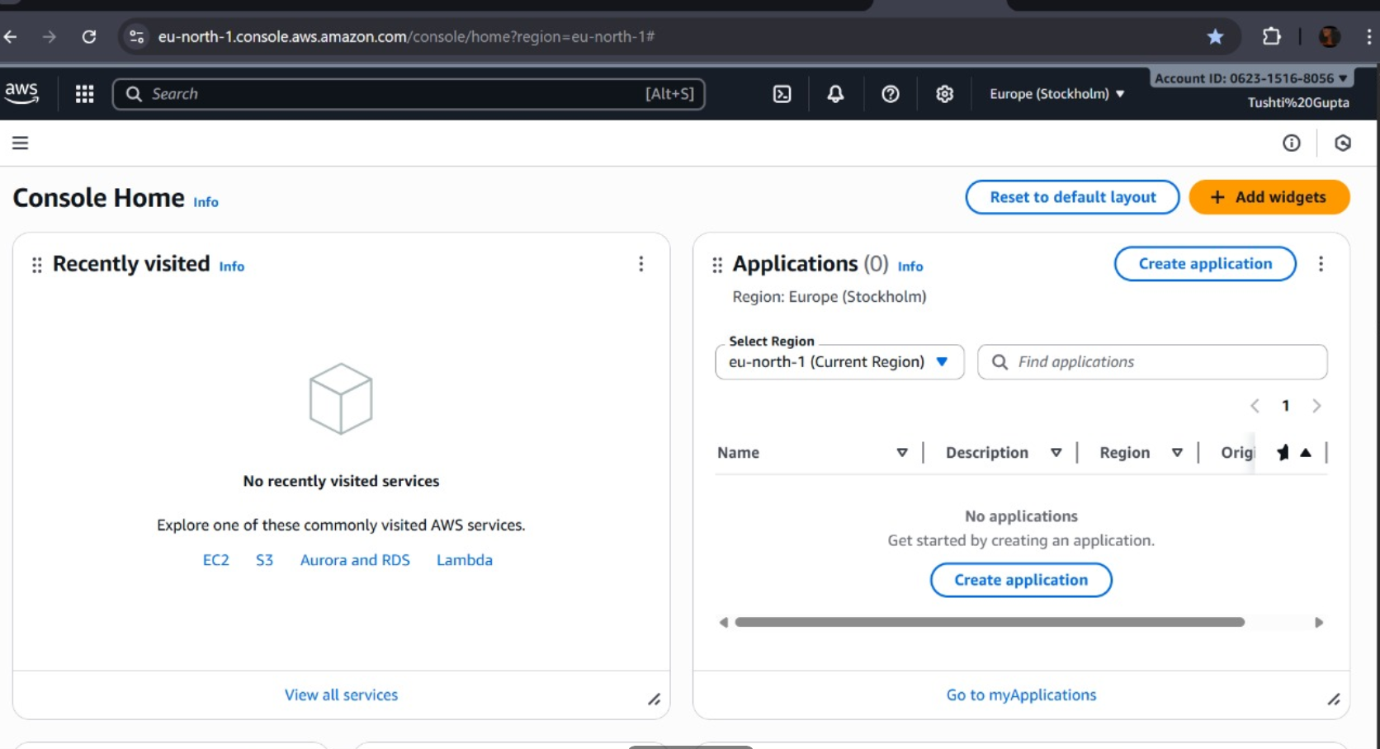

* Steps:

1. Go to the **AWS Management Console** → <https://aws.amazon.com/console>.
2. Click **Sign in as root user**.
3. Enter the **email address** (used when creating the account).
4. Enter the **root password**.
5. (If MFA is enabled) Enter the **MFA code**.
6. After entering the **MFA code,** root user will be created

* 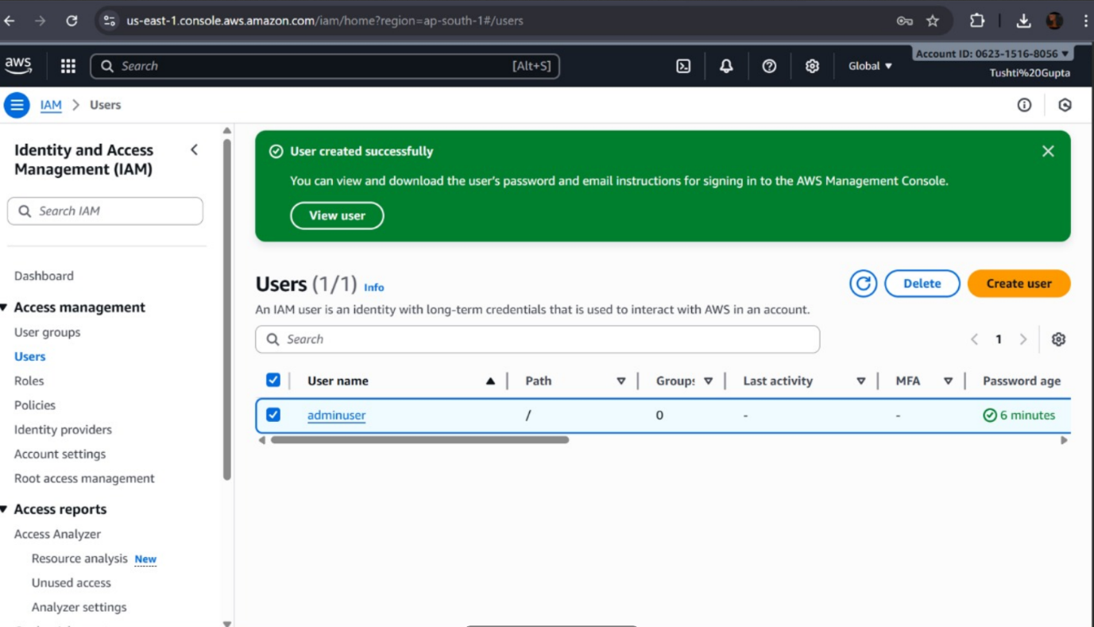**Task 2: Root-Equivalent IAM User Creation**

IAM user created as:--**adminuser**

* Steps:

**Step 1: Sign in as the Root User**

* Go to the [AWS Management Console](https://aws.amazon.com/console).
* Click **“Sign in as root user”**.
* Enter the **root email** and **password**.
* (If MFA is enabled, enter the MFA code.)

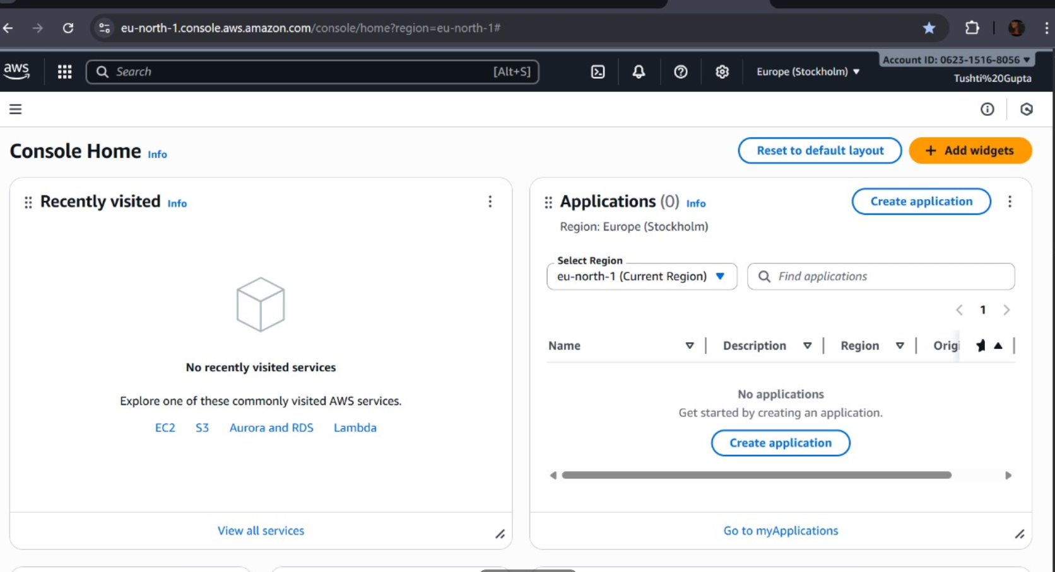

**Step 2: Open the IAM Console**

* In the AWS console search bar, type **“IAM”**.
* Click **IAM (Identity and Access Management)** to open it.

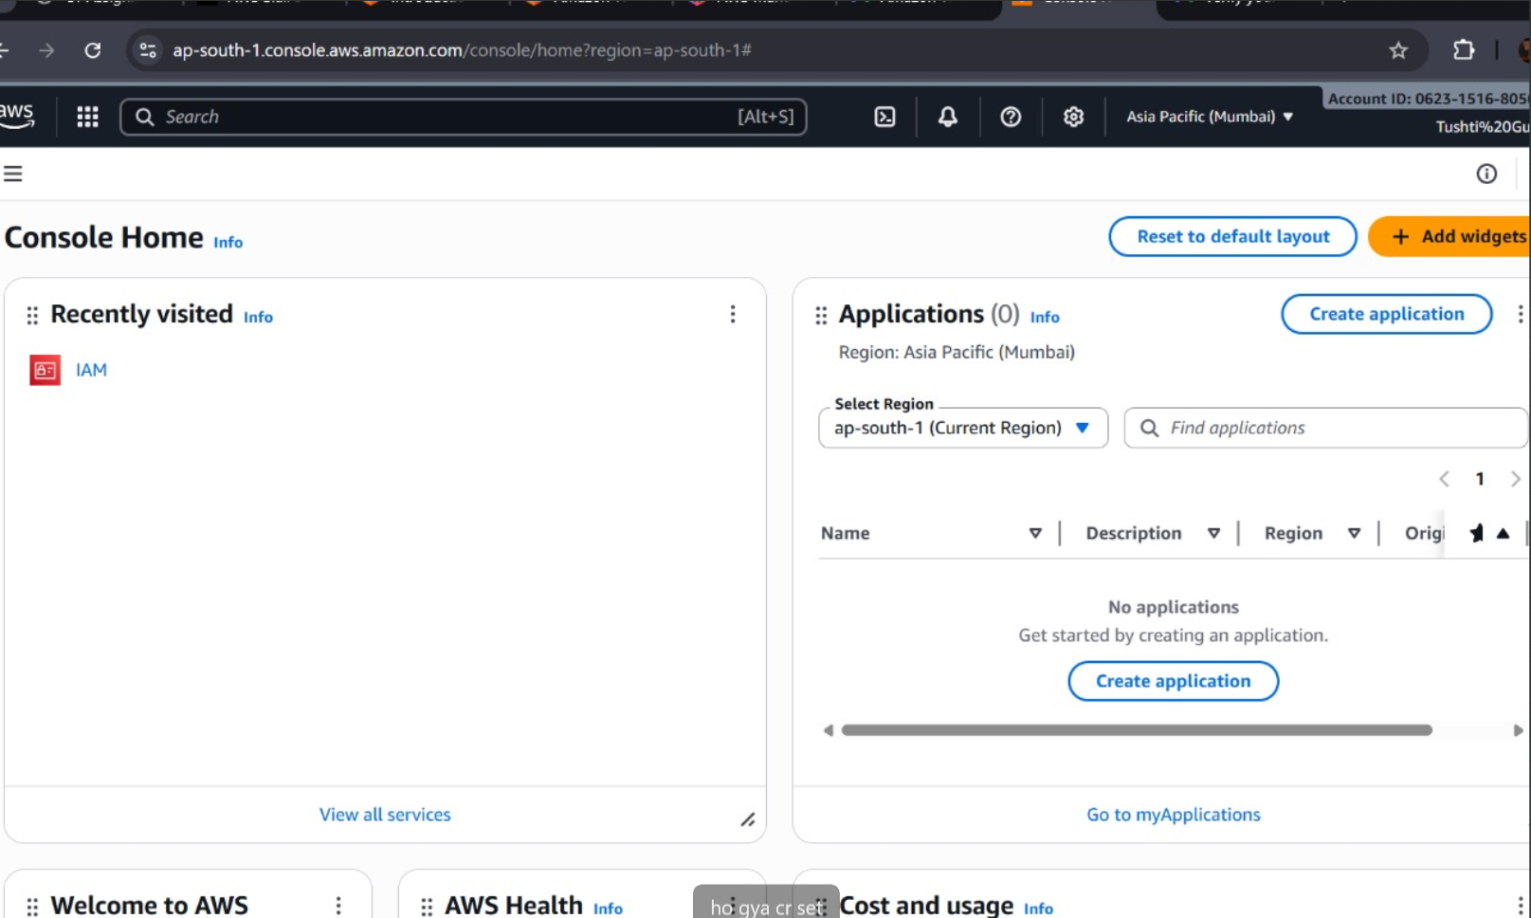

**Step 3: Create a New IAM User**

1. In the left sidebar, click **Users → Add users**.
2. Enter a **username** (e.g., admin-user).
3. Under **Select AWS access type**, choose:
   * ✅ **Password - AWS Management Console access** (if user needs console access)
   * ✅ **Access key - Programmatic access** (if user needs CLI or API access)

Click **Next**.

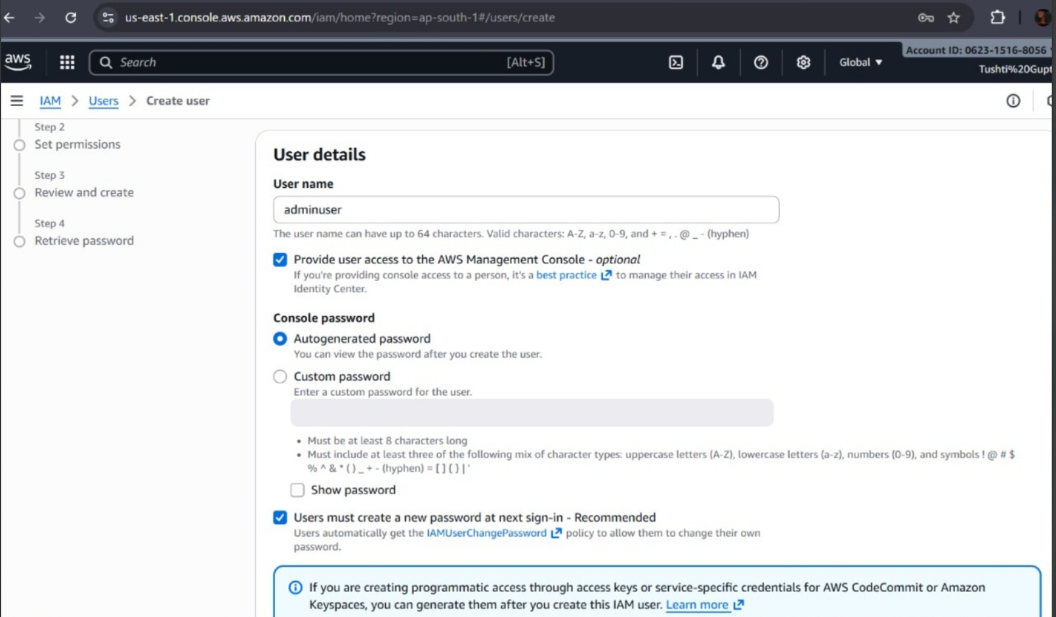

**Step 4: Attach Administrator Permissions**

1. Choose **Attach policies directly**.
2. Search for and select **AdministratorAccess**.
   * This gives the user full permissions for all AWS services (like the root user, but still restricted by IAM).
3. Click **Next**.

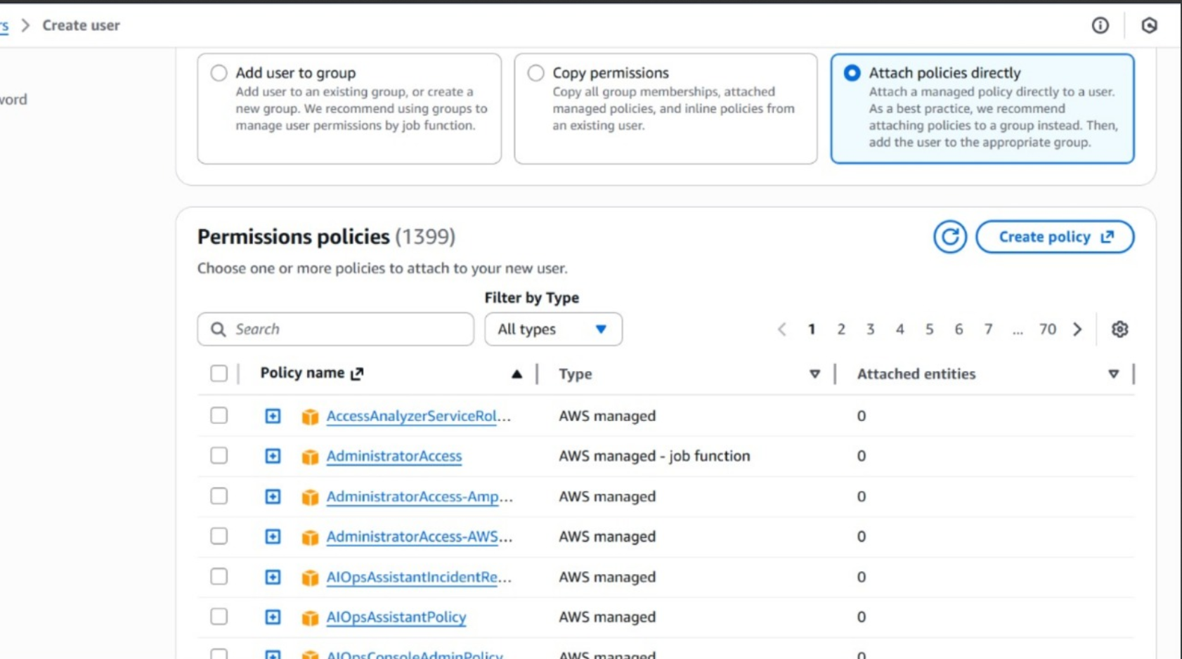

**Step 5: Review and Create**

* Review all details.
* Click **Create user**.

AWS will show the **login URL**, **username**, and (if applicable) the **password** or **access keys**.

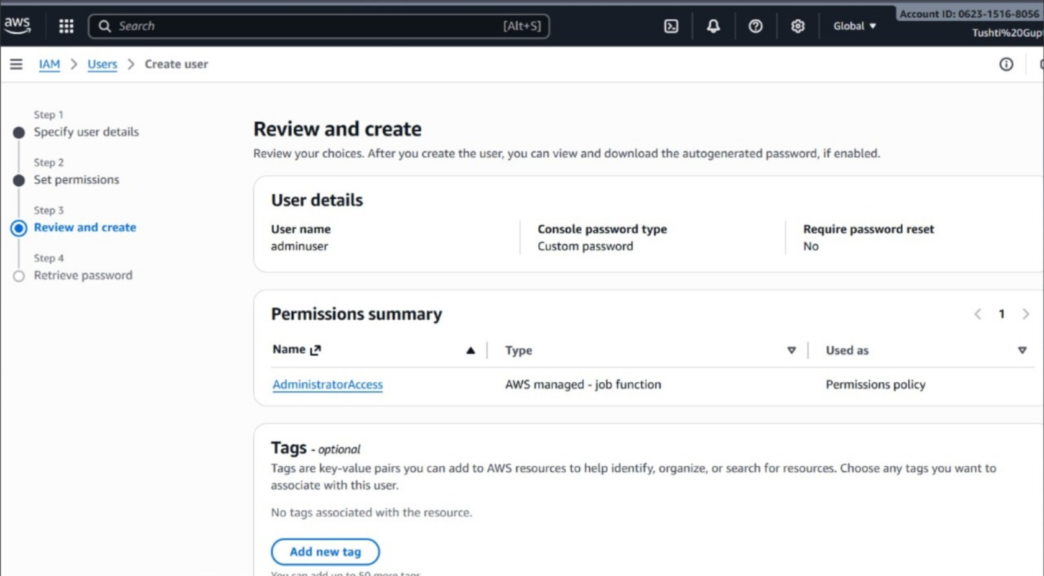

**Step 6: Secure the Account**

1. **Sign in as the new IAM user** to confirm it works.
2. **Enable MFA** (Multi-Factor Authentication):
   * Go to **IAM → Users → [your user] → Security credentials**.
   * Under **Multi-factor authentication (MFA)**, choose **Assign MFA device**.
   * Use an **authenticator app** (like Google Authenticator).
3. Store credentials securely (not in plaintext).

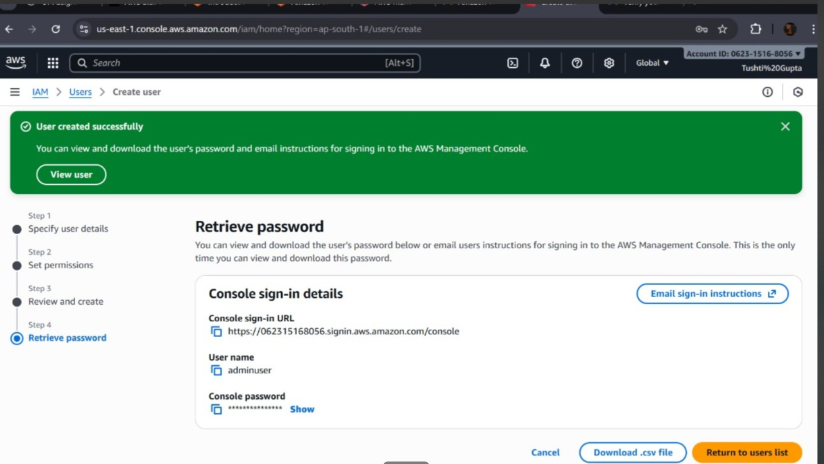

* 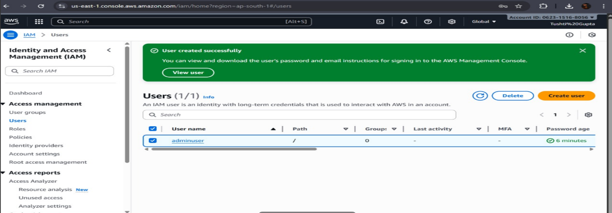Hence, IAM user created as **adminuser**
* **Task 3: VPC Selection & Region Choice**

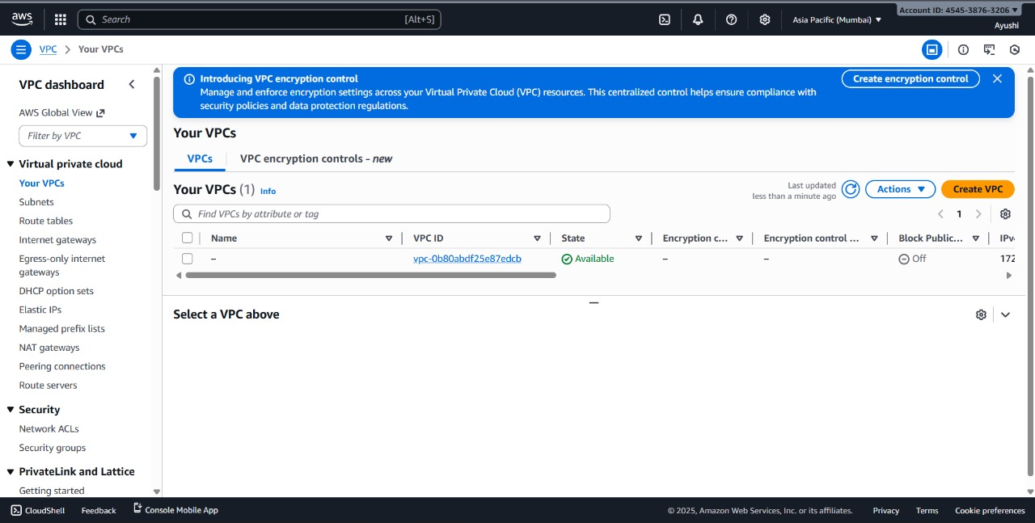

VPC created

* Steps:

**Steps to Select or Create a VPC**

1. In the AWS console, go to the **VPC Dashboard** (search for “VPC”).
2. Click **Your VPCs** in the left sidebar.
3. You’ll see a **Default VPC** (it usually has “Default” in the “Name” column).
4. You can use this VPC directly for EC2, RDS, or other resources — it already has:
   * Public subnets in each AZ
   * Internet Gateway attached
   * Route tables set up

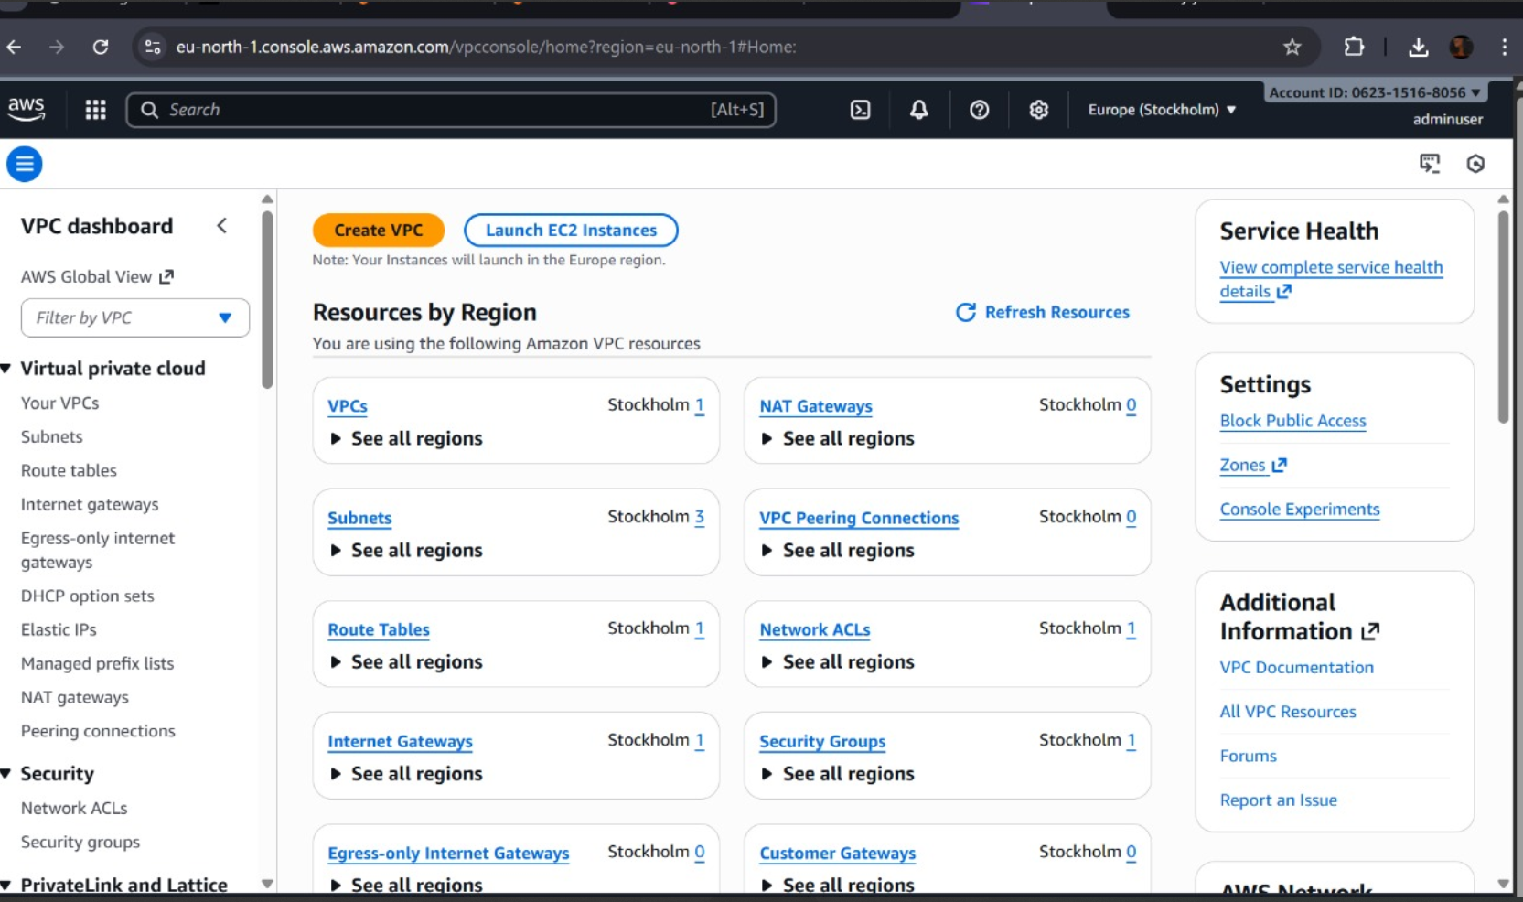

* **Task 4: Windows Web Server EC2 Instance**

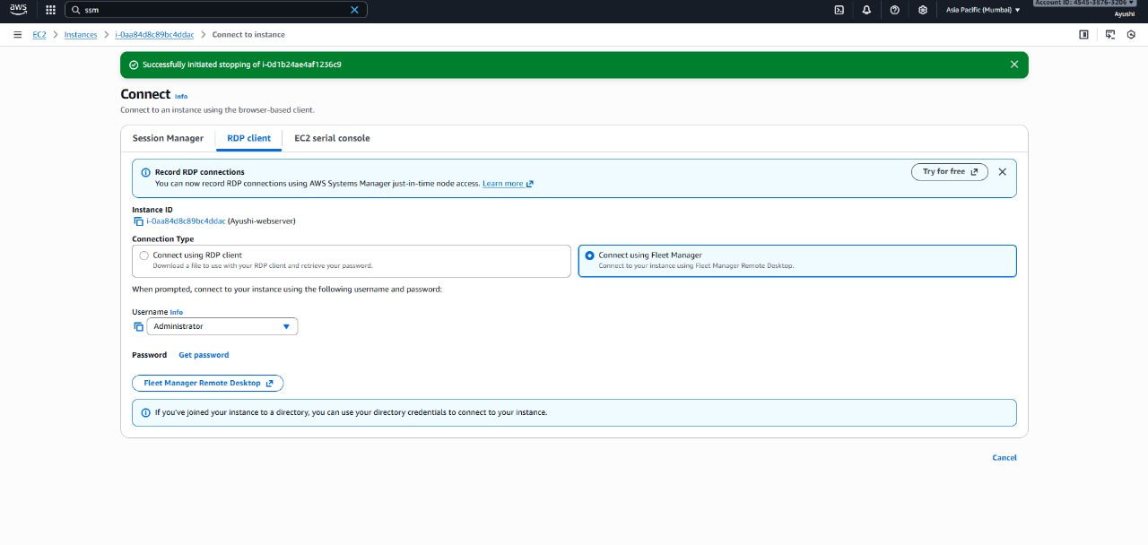

EC2 instance launched

* Steps:

**Step 1: Sign in and Select a Region**

1. Go to the [**AWS Management Console**](https://aws.amazon.com/console).

In the top-right corner, choose your **AWS Region** (e.g., Asia Pacific (Mumbai) ap-south-1).

* + All resources you create will reside in this region.

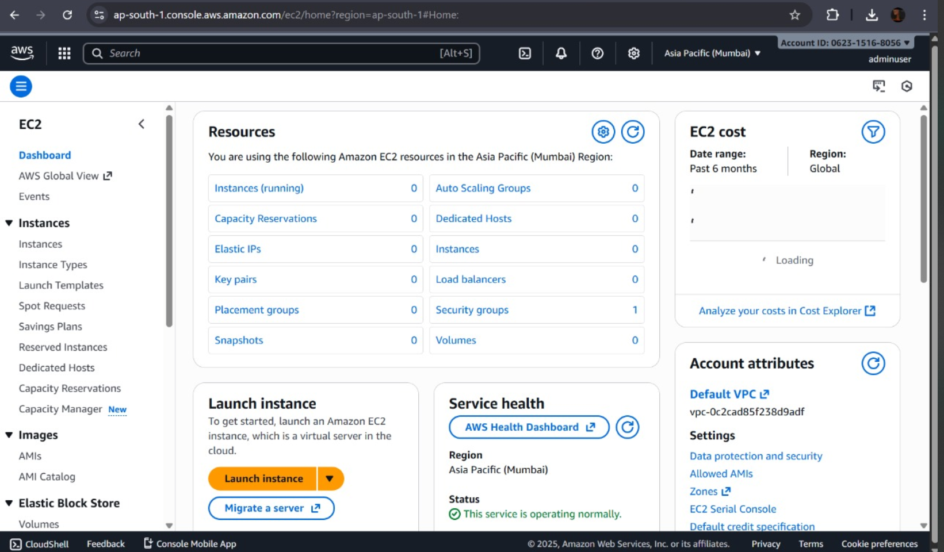

**Step 2: Open the EC2 Dashboard**

1. In the AWS Console search bar, type **“EC2”** and select it.
2. Click **Instances → Launch instances**.

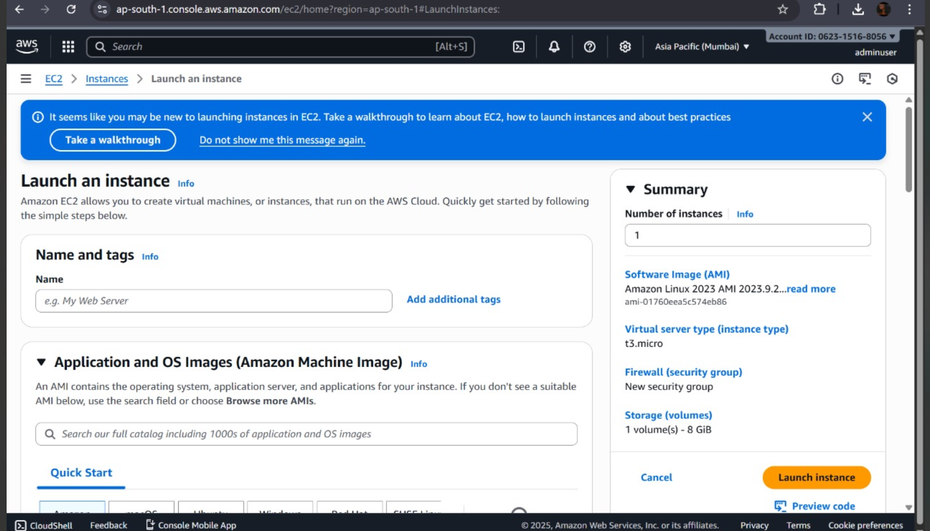

**Step 3: Configure Basic Details**

1. **Name your instance** — e.g., Windows-WebServer.
2. **Choose an Amazon Machine Image (AMI):**
   * Scroll to find **Microsoft Windows Server 2022 Base** (or 2019/2016 if needed).
   * These AMIs come with Windows preinstalled.
3. **Choose Instance Type:**
   * For basic setups, select t3.micro or t2.micro (Free Tier eligible).

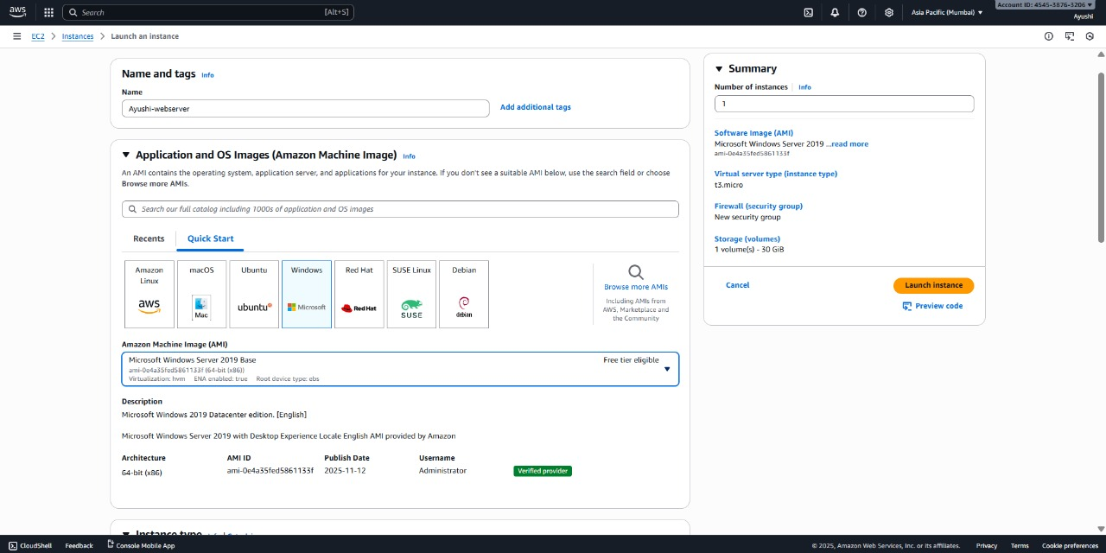

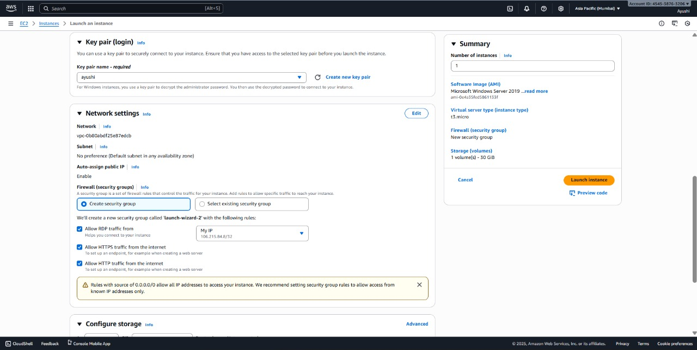

**Step 4:**

**Configure Key Pair (Login)**

1. Under **Key pair (login)**, choose:
   * **Create new key pair** (if you don’t have one yet).
   * Give it a name (e.g., WindowsKeyPair).
   * Choose **Key pair type: RSA**, and **File format: .pem** (for RDP decryption).
   * Click **Create key pair** — it will automatically download the .pem file to your computer.  
     ⚠️ Keep it safe — you’ll need it to connect later.

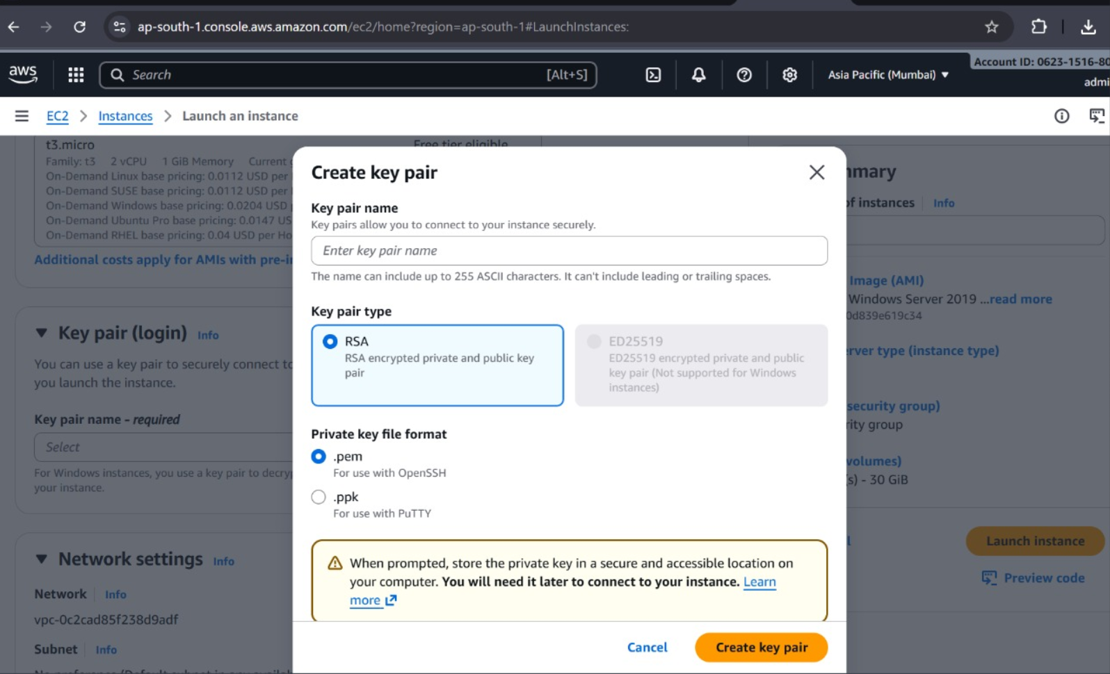

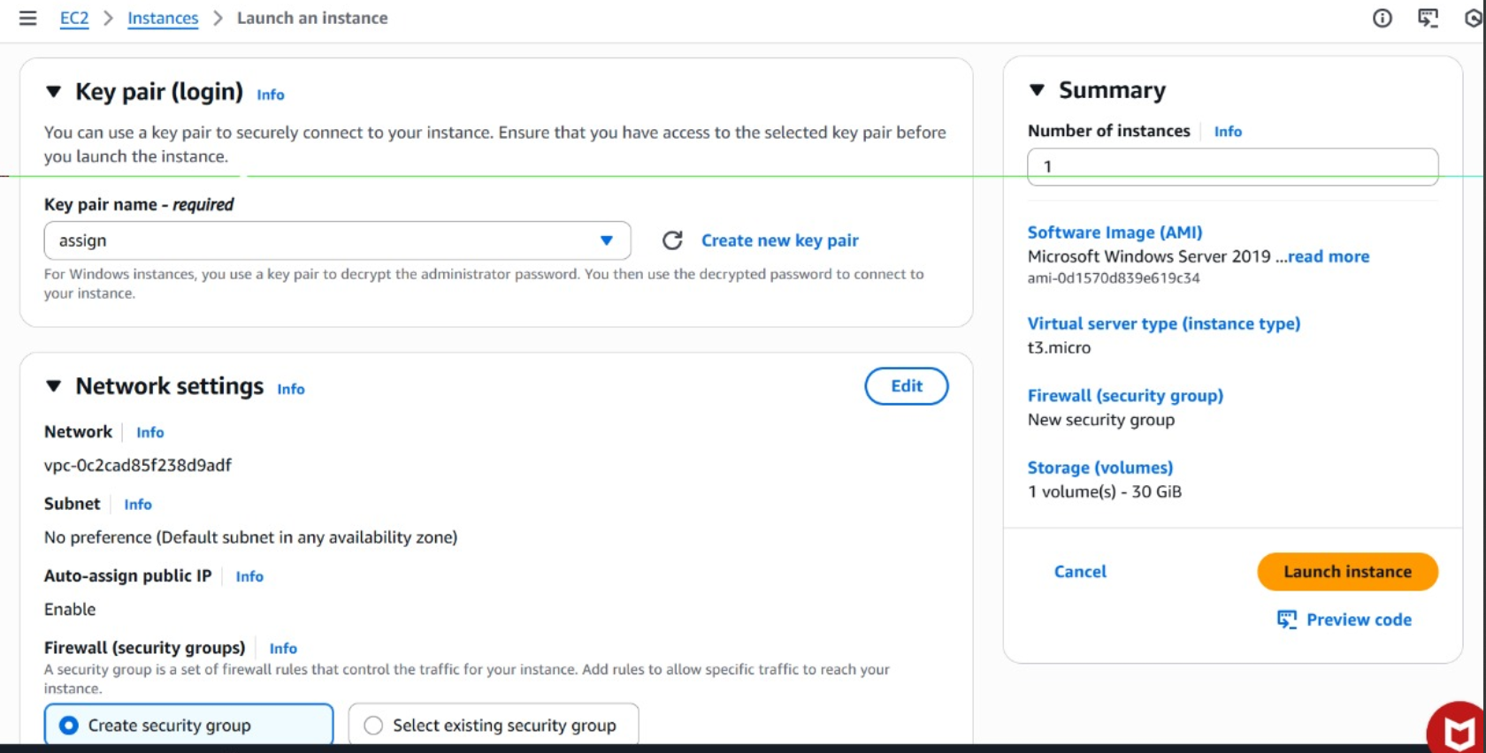

**Step 5: Configure Network Settings**

1. Under **Network settings**, select your **VPC** and **Subnet** (default VPC is fine).
2. Check **Auto-assign public IP** → *Enable*.
3. Under **Firewall (security group)**:
   * Choose **Create security group**.
   * Allow:
     + ✅ **RDP (Port 3389)** → Source: My IP (for remote access)
     + ✅ **HTTP (Port 80)** → Source: Anywhere (for web traffic)



**Step 6: Configure Storage**

* Default 30 GB is fine, or increase if needed.
* Ensure volume type is **gp3** (default).

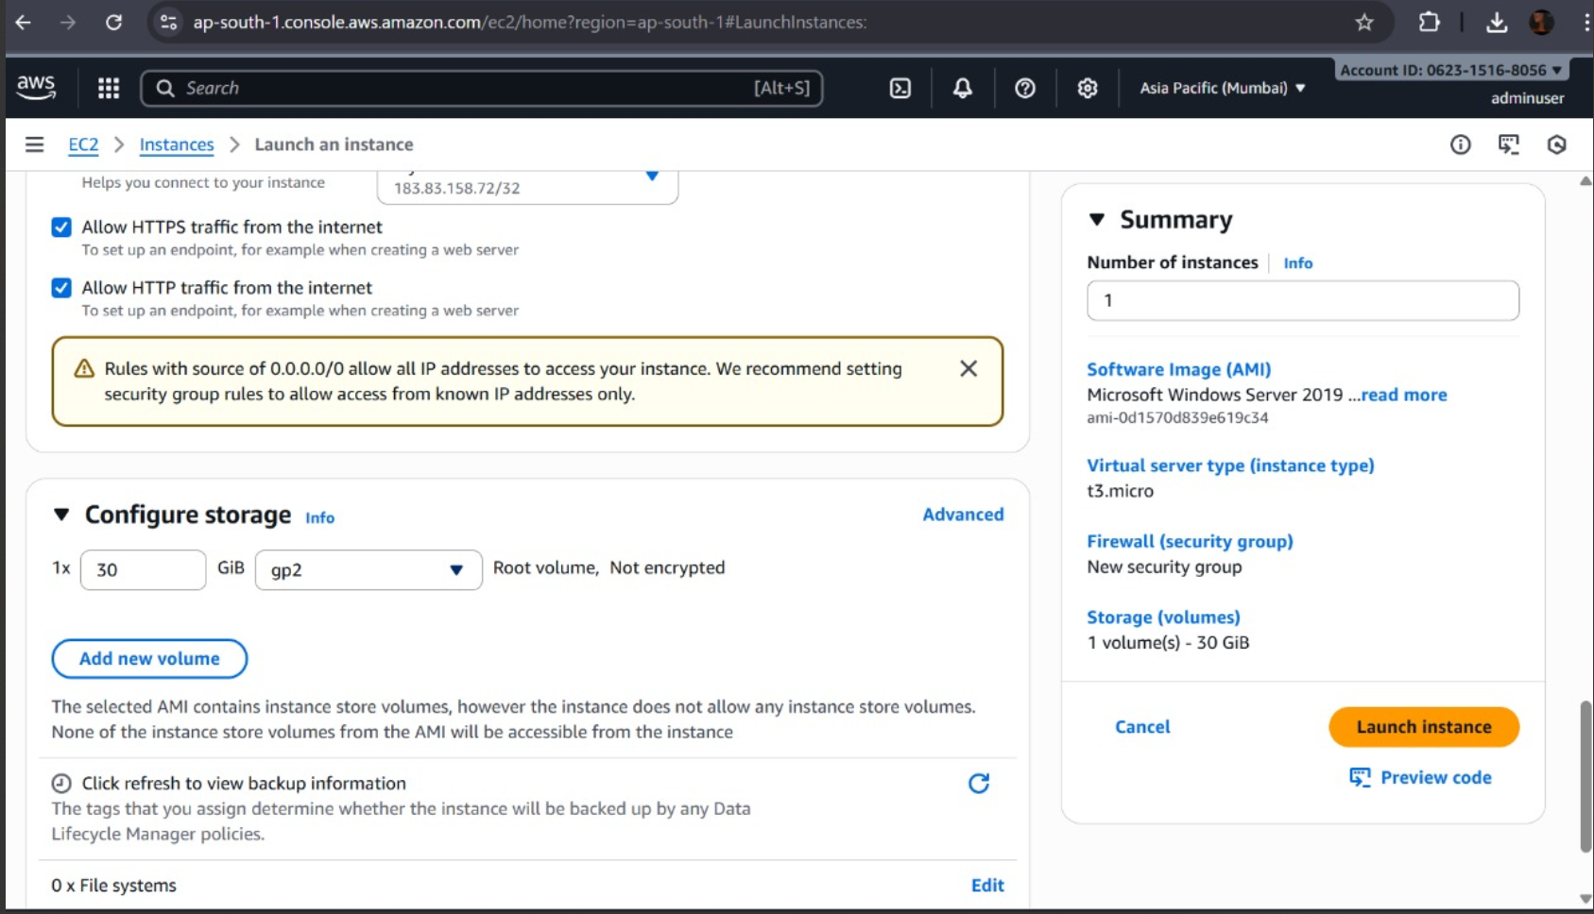

**Step 7: Launch Instance**

* Review your settings and click **Launch instance**.
* Wait a few moments until the status shows **running**.

**Task 5: Systems Manager Fleet Manager Setup**

* Steps:

**Step 1: Create IAM Role for Systems Manager**

Fleet Manager requires the instance to have permission to communicate with SSM.

**Steps:**

1. Go to **IAM → Roles → Create role**.
2. Under **Trusted entity type**, choose **AWS service**.
3. Choose **EC2** → Click **Next**.
4. In **Permissions policies**, search and select:
   * AmazonSSMManagedInstanceCore
5. Click **Next**, name the role:
6. SSM-Managed-Instance-Role
7. Click **Create role**.

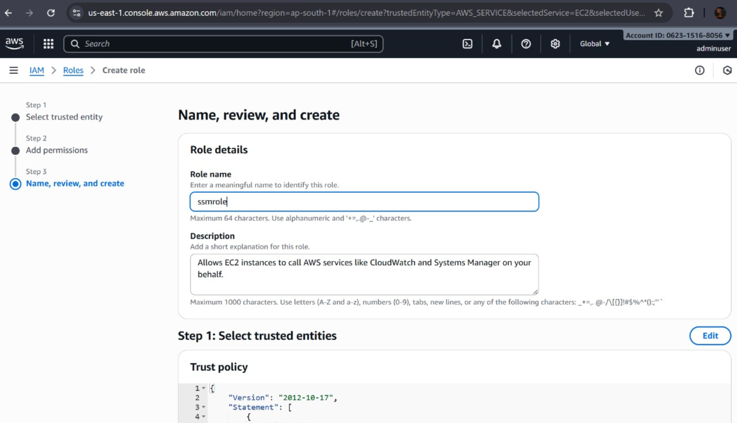

**Step 2: Attach IAM Role to EC2 Instance**

1. Go to **EC2 → Instances**.
2. Select your instance → **Actions → Security → Modify IAM role**.
3. Select SSM-Managed-Instance-Role → click **Update IAM role**.

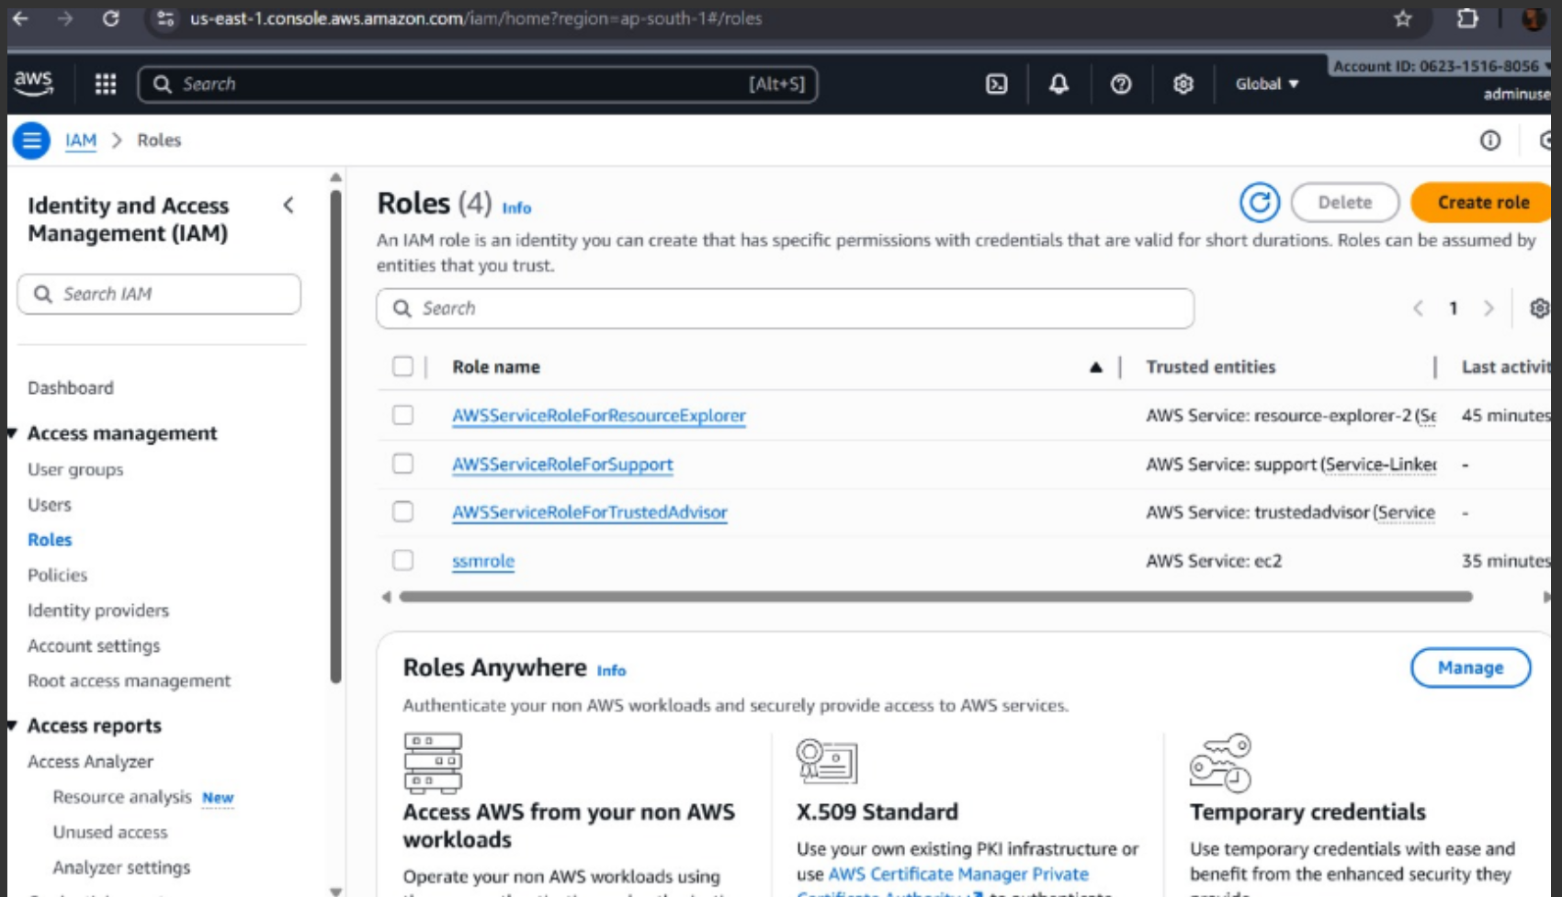

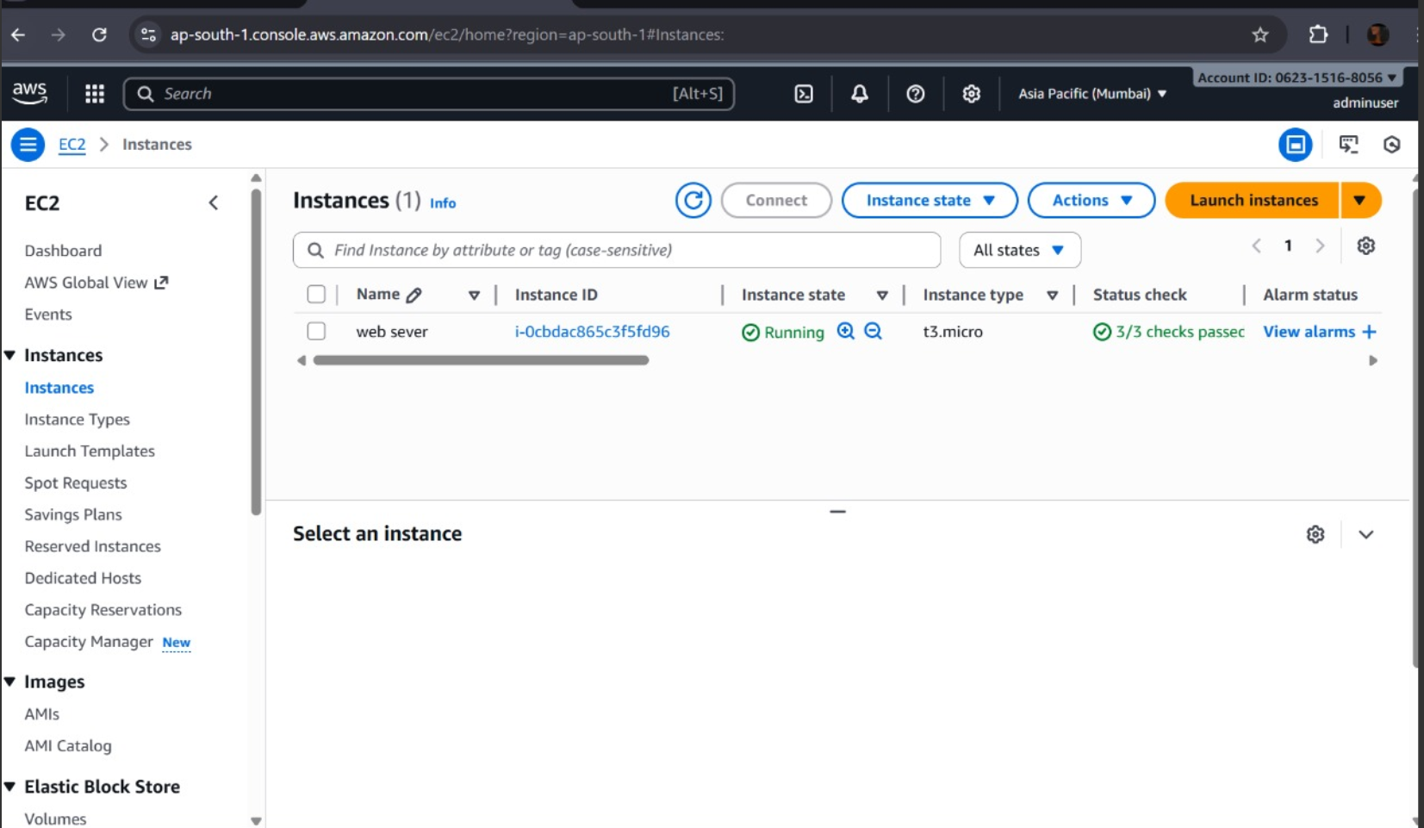

**Step 3 Verify SSM Agent is Installed**

**For Amazon Linux 2 or Windows:**

* The **SSM Agent** is preinstalled.

**For Other OS (e.g., Ubuntu, CentOS):**

1. Connect via SSH or RDP.
2. Run these commands:

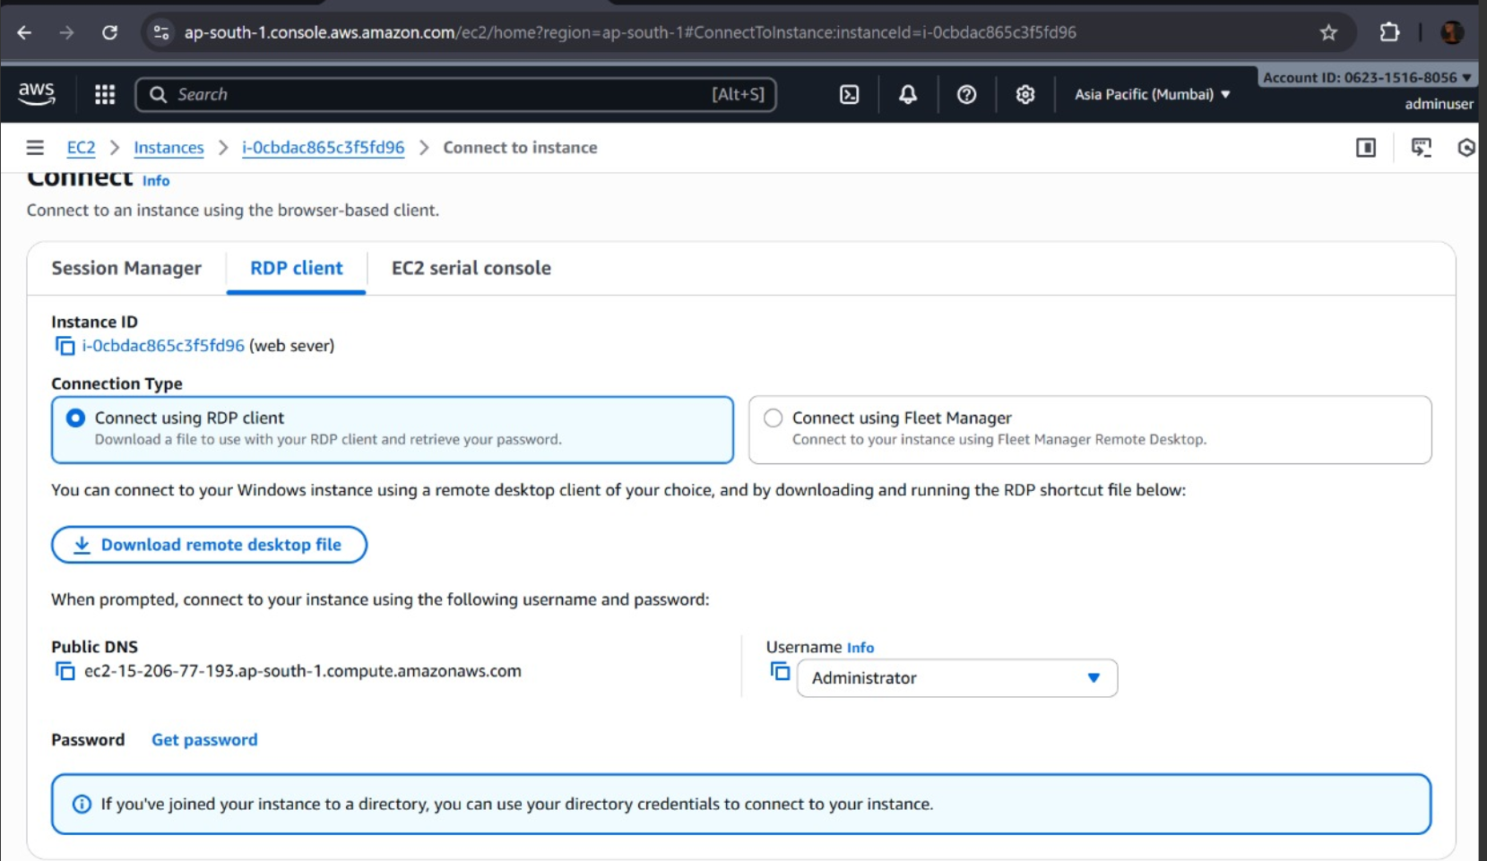

**Step 4: Open Fleet Manager**

1. In the AWS Console, go to **Systems Manager**.
2. In the left menu, under **Node Management**, click **Fleet Manager**.
3. You should now see your EC2 instance **listed**.
   * If it doesn’t appear yet, wait a few minutes for SSM to register it.

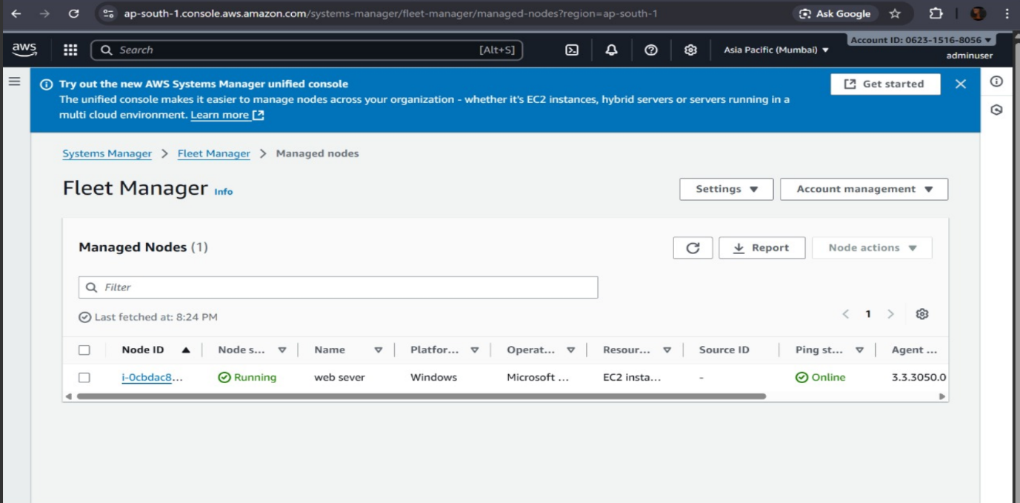

**Step 5: Manage Instance via Fleet Manager**

Now you can manage your EC2 instance **without RDP or SSH**:

**From Fleet Manager Dashboard:**

* Select your instance → click **Node actions** or instance name.  
  You can now:
* View system info (CPU, memory, network, OS details)
* Browse and edit files
* View event logs
* Manage users
* Run PowerShell/Command Line directly in console
* Access the Windows registry (for Windows)
* Reboot or stop instance remotely

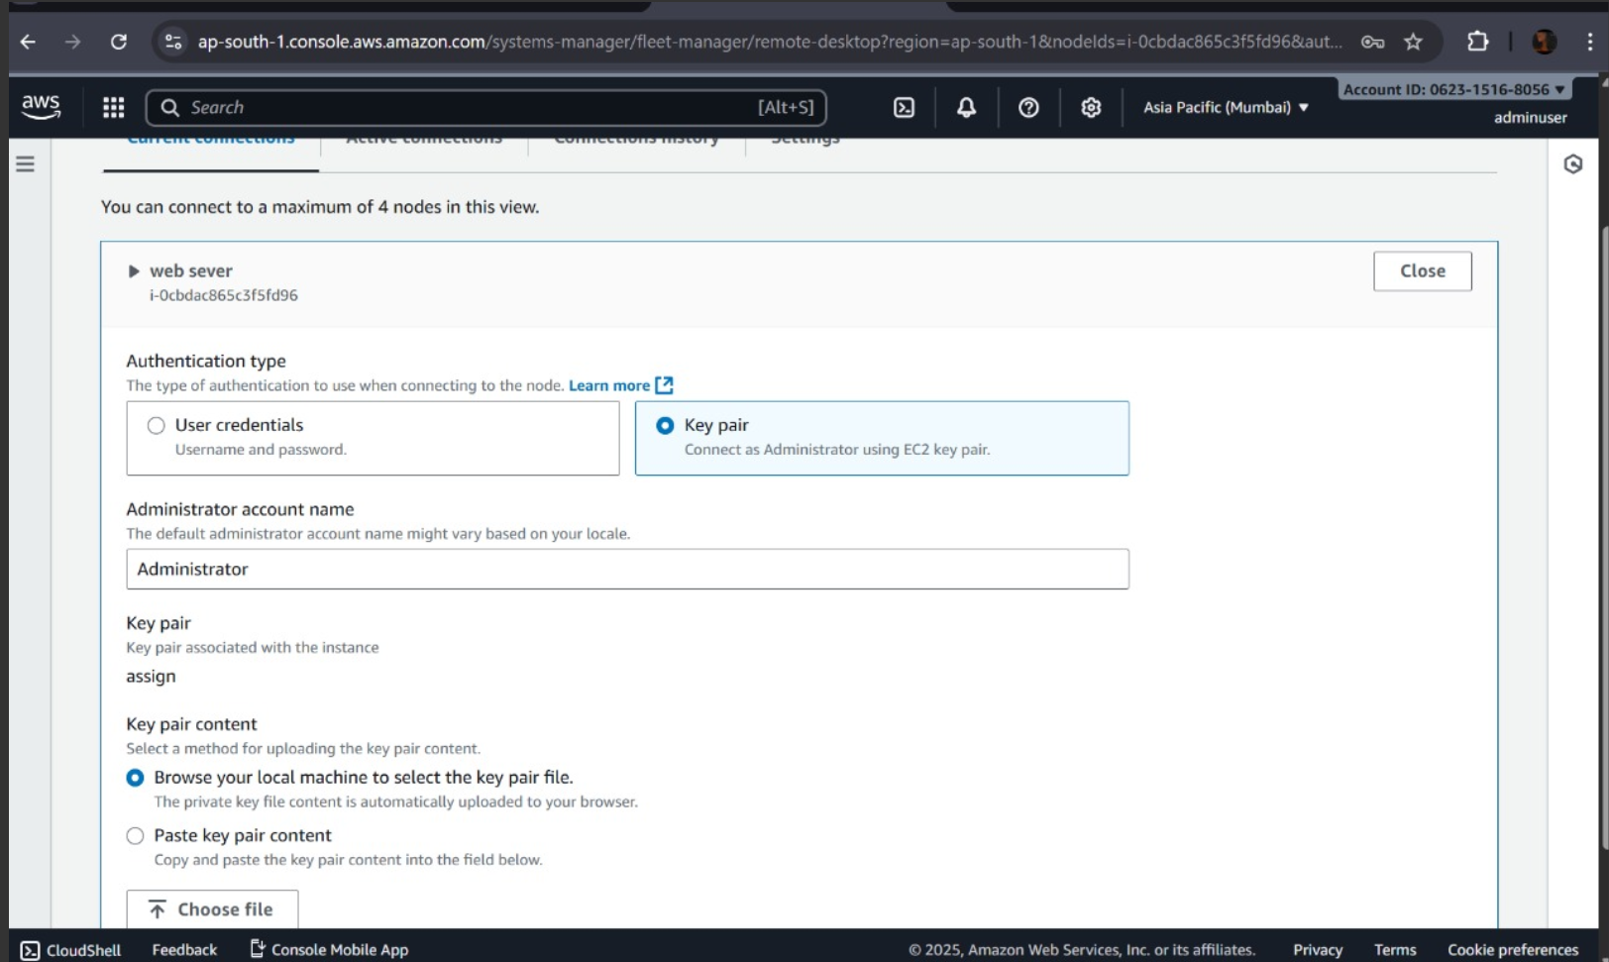

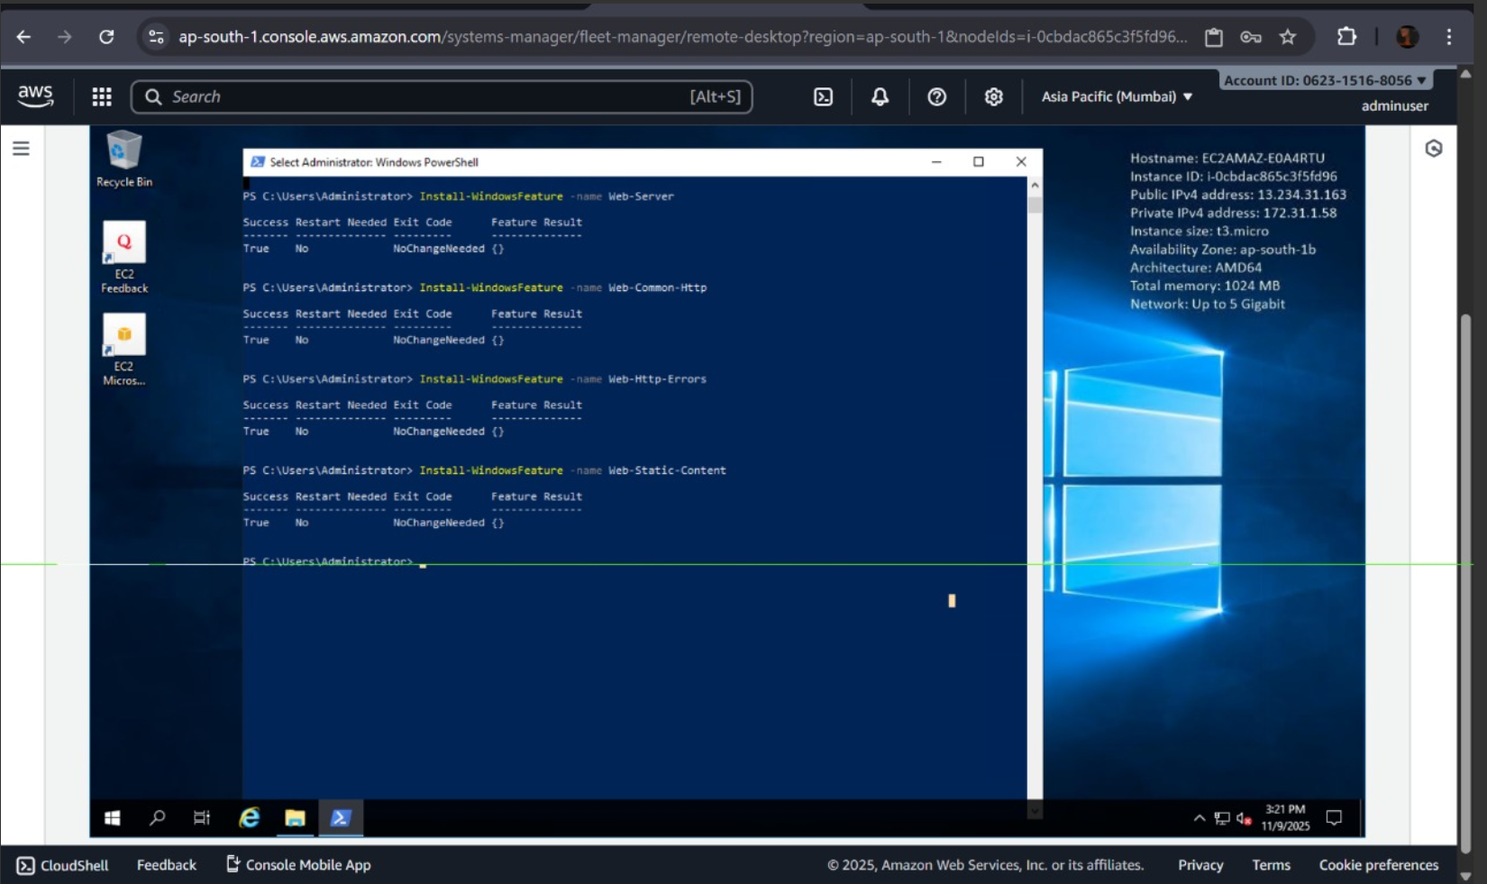

Final Output:

